**Valuation Case Study: Jazz Pharmaceuticals [JAZZ] – How to Make an Investment Decision**

**Step 1 – Reviewing the Numbers**

For a case study like this, **always start with the numbers.** You will not have enough time to fully research all the qualitative factors, survey doctors, or anything like that, so focus on the work **you** did and use that to make your decision.

If the numbers indicate that the company is **overvalued**, even with aggressive assumptions for pricing and volume increases, then you should lean toward making a **short** recommendation (i.e. you’re betting that the stock price will decline).

If, on the other hand, the numbers indicate that the company is **undervalued**, even with relatively conservative assumptions, then you should lean toward making a **long** recommendation (betting that the stock price will rise).

If the numbers are ambiguous or indicate that the company is valued appropriately, then you *could* go with a **neutral** recommendation. However, you *generally* want to take a positive or negative view in interviews – unless it’s a company they assigned to you.

In these “borderline cases,” another option is to reach a view and then find qualitative / quantitative factors to support your reasoning… and then “hedge” yourself by saying that you’d recommend longing/shorting the stock, but you would use protective options to greatly limit your losses, perhaps to around 5-10% at the most.

In this case study, the company is clearly undervalued – at least if you believe our own numbers for the Xyrem pricing increases and market penetration – because almost all the sensitivity tables indicate an intrinsic value higher than the current share price.

To show you a more interesting example, however, let’s use the **“Base Case” numbers** from the investment banking pitch book presentation, which assume a (50%) differential to the pricing increases, a (20%) differential to market penetration, and a Xyrem generics entrance in FY21.

When you change these assumptions, the data becomes a lot more ambiguous:



If we think the Discount Rate is 8.0%+ and that the company will have zero to negative long-term FCF growth, it seems **overvalued to appropriately valued**; if we believe the Discount Rate will be lower and/or the Terminal Growth Rate will be higher, it seems **undervalued**.

You can see how the original version of the table, with our own numbers, is a much more clear-cut case:



In real life, it is **rarely** this straightforward – for 95% of companies, you’ll get a result closer to the first table above.

So when that happens, you need to go a step deeper and look at your **sensitivity tables**, specifically focusing on the assumptions you’re most uncertain of.

**Step 2 – Sensitizing the Assumptions You’re Most Uncertain of and Deciding Based on Those**

If the basic analysis doesn’t tell you much, the next step is to look at your sensitivity tables and figure out which ranges are more likely or less likely.

This step assumes that you **already** have sensitivity tables based on the best variables to sensitize – ones that:

1. Make a significant impact on the model output.
2. Are easy to reduce to a single cell.
3. Could conceivably change over time as a result of the company and the market.

For example, in this case study, the **Xyrem generics entrance year**, the **Xyrem annual price increases**, and the **Xyrem market penetration** would be the prime candidates for the sensitivity tables.

Remember our **narrative** for Jazz, discussed in the first few lessons of the valuation module:

1. **Market Size for Xyrem Much Bigger than Expected** – We think up to 25% of total potential patients might be on the drug eventually, up from 5-10% now.
2. **Pricing Can Also Increase by Up to 2x Over Time** – The long-term price might be $120K per patient per year, which reflects only modest 10-15% price increases each year... compared to 40-60% price increases historically.
3. **Xyrem Generics Won't Be Here for a Long While** – We think a FY22/FY23 entrance is more likely, as opposed to the consensus estimates of a FY18/FY20 entrance.
4. **Other Drugs** – We don’t have a strong view on Erwinaze, but we think that the Defitelio price and market share will both increase by more than anyone expects. JZP-110 is also promising and could start replacing Xyrem revenue by the end of this 10-year period.

So it is worth “testing” all of these assumptions with sensitivity tables, even if we don’t include all the tables in the final analysis.

Here, for example, drugs like Defitelio and JZP-110 do not make a huge impact on the company’s intrinsic value because they generate less revenue to begin with.

It also would not make sense to sensitize the Balance Sheet or Cash Flow Statement drivers, because they do not make a big impact in this model (Working Capital and CapEx are both minimal for this type of company).

You can look at dozens of tables, but you should **focus on the assumptions you are most uncertain of.**

The company states several times that they estimate 157,000 potential patients for Xyrem, for example, so there is not much room for interpretation there.

The patient numbers for the other drugs are similarly constrained.

**However, there is a lot more uncertainty around the Xyrem assumptions** in this case study because the “ceiling price” is unclear, as is the effectiveness of the marketing campaigns to boost the # of patients; then there’s the matter of generics entering the market.

We’re fairly confident that both pricing and volume can expand by more than the consensus views, and that generics will enter the market later than expected – but we also want to see **what the valuation impact of those assumptions is**.

To assess this, we will use the “Base Case” numbers (from the IB pitch book presentation), but we will **hard-code** the market penetration and pricing growth figures, effectively making the baseline, pre-toggle numbers much lower:

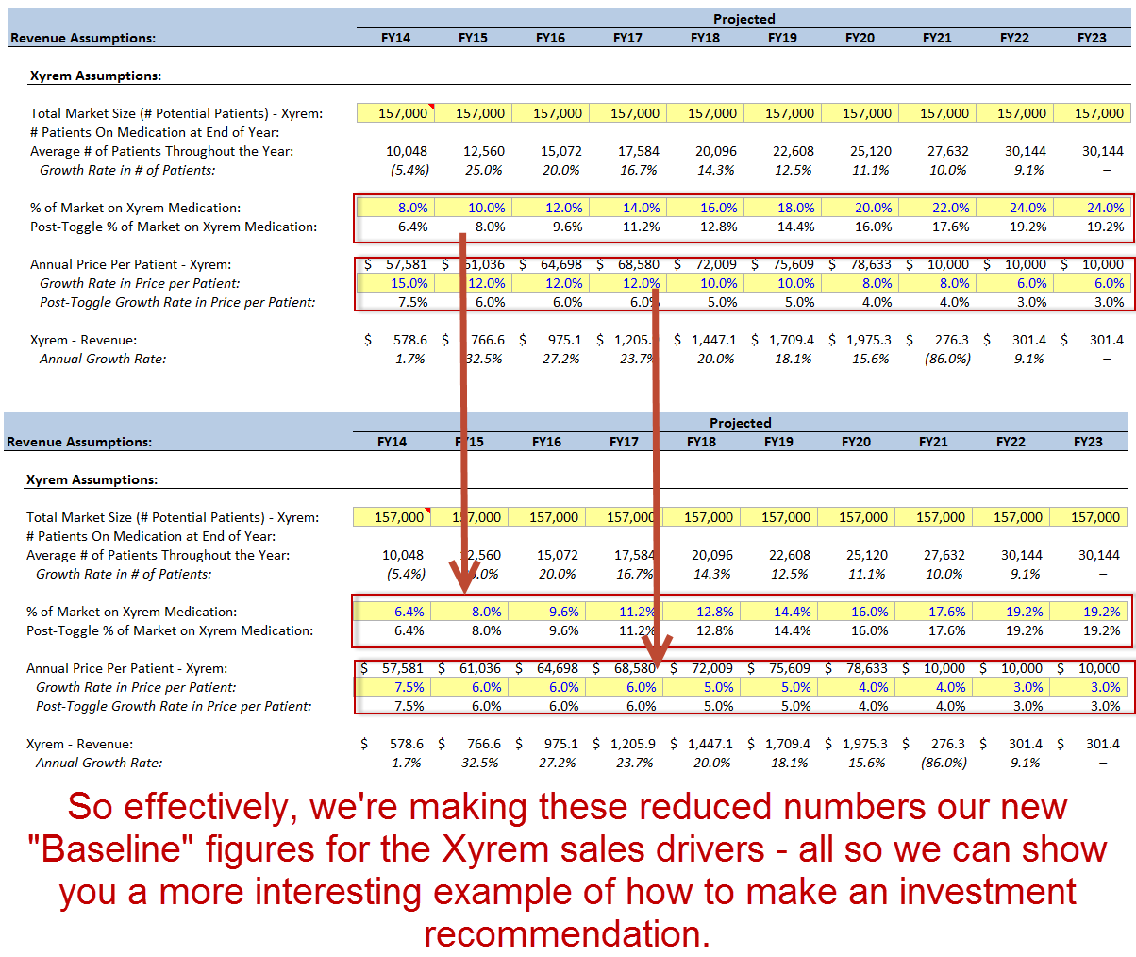

Once we have these new, more conservative Baseline figures for Xyrem, we can begin testing the 3 assumptions that matter most: **pricing increases**, **market penetration**, and the **generics entrance year**.

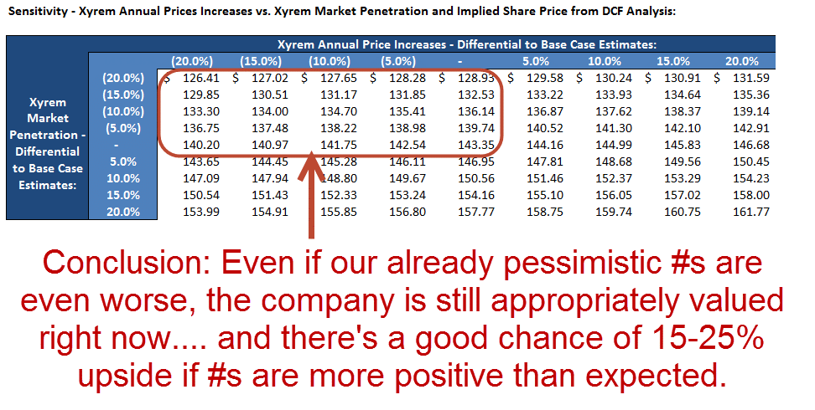

So far, even with these Base Case numbers, this is looking like an **undervalued** company because its current share price is still **below the “middle price” in this table** ($143.35).

Even if Xyrem price increases and market penetration are both 20% *worse* than consensus estimates, the company is *still* appropriately valued at its current share price.

And if they’re 20% *better*, that equates to an implied share price of $150.00 – $160.00, representing 15-25% upside.

And remember: our own set of numbers (the “Management Case”) will make this company even more undervalued because the Xyrem sales are over 2x higher there.

It’s also worth considering an “extreme” downside scenario where the price increase and market penetration percentages are up to 80% lower than these Base Case estimates:

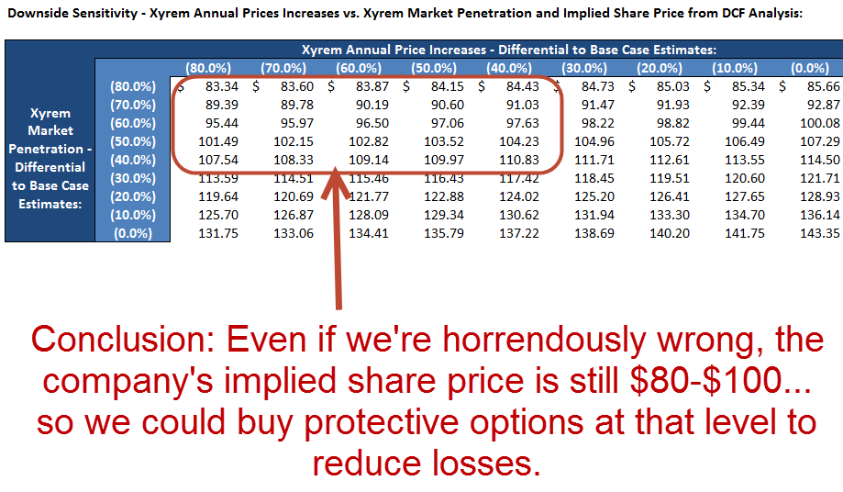

It’s also interesting to note that even with a moderate 10-20% discount to our estimates, the company *still* appears to be appropriately valued to a bit undervalued.

Next, we can look at the Xyrem generics entrance year vs. the pricing increases:

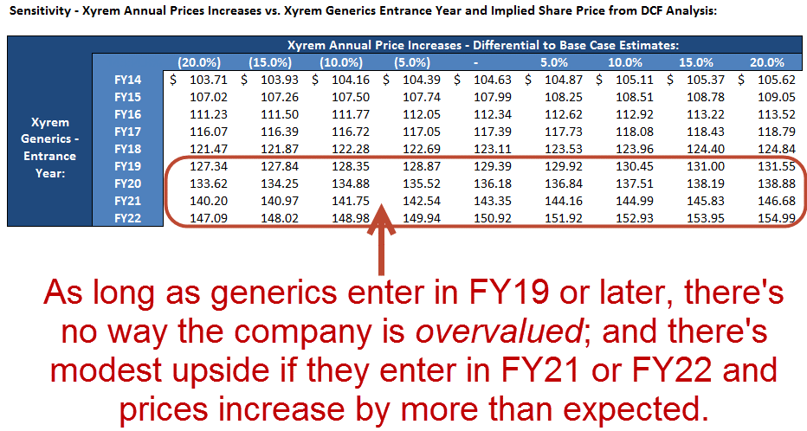

Based on all these tables so far, it’s clear that:

* Even if we’re modestly *wrong* on many of these assumptions, the company’s current share price implies an appropriate valuation.
* If the Base Case estimates are exactly true, the company is undervalued by a bit.
* And if the numbers are modestly above the Base Case estimates, the company is undervalued by 15-25%.
* Even if the generics entrance year is FY19, it’s still not a disaster because the implied share prices are close to the company’s current share price.

So this company is looking like a good **long** candidate, though admittedly there is not much upside with the Base Case numbers.

Now, we might want to look at some of the other assumptions / sensitivity toggles, such as the Defitelio pricing and market penetration figures:

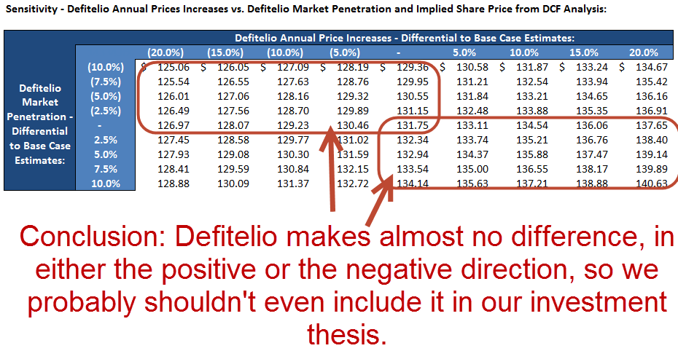

You would get similar results by looking at sales of JZP-110 or the “Other” segment, so we’ll also exclude those.

**This is important because investing is also about determining what is NOT important and then eliminating those assumptions from your analysis and investment thesis.**

In many cases, a company is mispriced because the market believes that one potentially negative aspect of the business is more important than it actually is. But your job as the investor is to separate fact from fiction and determine whether or not that *really* matters.

So here’s our overall conclusion based on this review of the sensitivity tables:

**“Based on the fact that we think that the company’s annual price increases for Xyrem and its market penetration will both be greater than expected, and that generics are more likely to enter the market in FY22, we think there’s a good chance that it’s undervalued. Additionally, even if the company’s prices or market penetration do not go up by as much as expected, or even if Xyrem generics enter the market earlier than expected, it is simply valued appropriately at its current levels.”**

The *actual* sensitivity tables we’ll use in the stock pitch, based on our more optimistic projections, will better reinforce these points.

Notice how we’re also dropping that part of our **narrative** about Defitelio and other drugs – because in practice, it doesn’t matter much for valuation purposes.

**Step 3 – Substantiating the Catalysts**

So now you have your basic view of the company established.

The next question is: “Will *specific events* (catalysts) push the share price toward the per share value you think the company is worth?”

Companies can stay mispriced for years or decades if there are no catalysts, so it’s critically important to get this right. A lack of solid catalysts could easily result in a strong recommendation becoming a much weaker recommendation, or no recommendation at all.

Catalysts do **NOT** need to refer to specific events that will happen – potential events are fine – but they **DO** need to refer to events within the next 6-12 months (at least, that is what most hedge funds, asset management firms, and equity research groups care about).

So something like a speculative acquisition that will only pay off in 5 years from now would **NOT** be a good catalyst.

There isn’t a real “formula” you can use to find catalysts, but here’s a real-life list taken from one of the equity research reports we looked at:

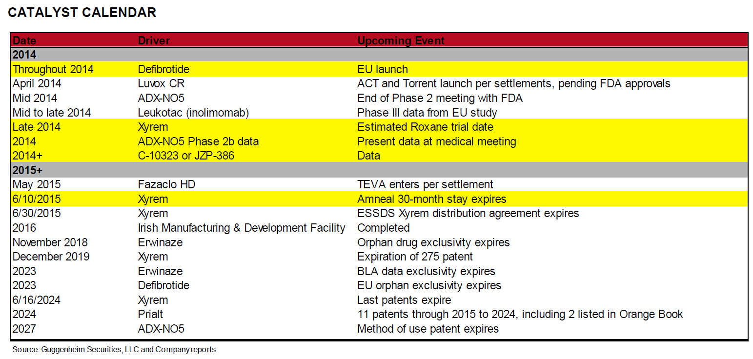

While they do list catalysts over 10 years in the future here, you should **NOT** use catalysts out that far into the future unless you’re specifically instructed to do so.

Here’s a list of potential catalysts for biotech / pharmaceutical companies:

* **Clinical Trial Results** (especially when a drug moves from one phase to the next phase)
* **New Product Launches** (e.g., JZP-110 and JZP-386 – they would be catalysts *in the future* when they actually launch)
* **Changes to Product Pricing** (e.g., the Xyrem price increases)
* **Changes to the Target Market** (e.g., the company’s outreach campaign to find more narcolepsy patients)
* **Launches of Existing Products into New Regions** (e.g., Defitelio entering the US market in the distant future – this would be a catalyst *near that future date*)
* **FDA Approval of New Drugs** (or equivalent government body in other countries)
* **New Patents or Drug Exclusivities**
* **Expiration of Patents / Drug Exclusivities and Generics Entering the Market** (e.g., the Xyrem patents expiring and generics entering the market)
* **Development of New R&D Facilities or New Manufacturing Facilities**
* **New Distribution or Royalty Agreements**
* **Lawsuits / Legal Settlements** (e.g., the potential Xyrem settlement with Roxane)
* **Acquisitions or Divestitures** (e.g., the Gentium acquisition which just closed in Q1 here – this *would have been* a catalyst in the prior year, though you could still point to the first earnings results after that acquisition as a catalyst)
* **Other M&A Deals in the Market** (e.g., the wave of “tax inversion” deals in the US around the time of this case study – those might prompt someone to bid on Jazz)
* **Earnings Announcements**
* **Competitors’ Activities**
* **Financing Activities**

For JAZZ, we already have several catalysts over the next 6-12 months:

* **Changes to Pricing / Target Market** – The company will most likely announce yet another price increase for Xyrem, and will also announce the effectiveness of the marketing awareness campaigns it has launched for patients suffering from narcolepsy.
* **Lawsuits / Legal Settlements** – Positive news from the Roxane case could make it more likely for generics to enter the market later than expected (i.e., past FY18-19).

Several others, such as the first earnings results from the Gentium acquisition and clinical trial results from pipeline drugs, could also be catalysts, but the ones above are better to use because **they tie in directly to our key assumptions and sensitivities.**

For **long** recommendations, you use positive catalysts (earnings beating expectations, positive clinical trial data or legal results, no pushback on price increases, etc.), whereas you use negative catalysts for **short** recommendations.

The argument would go something like: “Once the company announces its upcoming price increase(s) for Xyrem, along with the results of the Roxane case and how effective its marketing campaigns for potential Xyrem patients have been, the market will realize that it has been greatly underestimating potential revenue from this drug and the company’s share price will rise accordingly.”

Then, your job in the presentation is to estimate the **per share impact** for these factors, via sensitivity tables and your existing model, tweaking it where necessary.

To come up with these catalysts, you need to speak with professionals in the industry (channel checks) and look at the company’s filings, investor presentations, 3rd party reports, press releases, and analyst commentary.

**The Bottom-Line:** If you *can* find reasonable catalysts to cite, proceed with your recommendation.

If you can’t, then you need to rethink what you’re saying and go back to Steps 1 or 2 – or, perhaps you should admit that even though this company may be mispriced, it is **not** necessarily a good candidate to long or short due to the lack of near-term catalysts.

**Step 4 – Determining the Risk Factors and How to Mitigate Them**

So now you’ve determined whether or not the company is overvalued or undervalued, and how *much* overvalued or undervalued it is – and if it is truly valued appropriately, you’ve thrown it out and have moved onto other potential investments.

You’ve also determined the **catalysts** – the specific events in the next 6-12 months that may move the stock price in the direction your valuation calls for. Furthermore, you’ve estimated the per share impact for these catalysts as best you can.

So you have a pretty strong case so far… but now you need to admit that **you might be wrong**.

The **risk factors section** is the single most neglected and poorly thought-out section of stock pitches, so if you get it right you’ll set yourself apart from everyone else.

The easiest way to come up with solid risk factors is to **reverse your catalysts** and say, “OK, what if these events do NOT occur as planned – for example, what if the company announces a lower-than-expected Xyrem price increase, a less effective-than-expected marketing campaign, or a negative outcome from the Roxane trial – what happens to the implied share price then?”

But you should also go beyond those risks and think about *other* developments that might result in the share price moving in the opposite direction:

* What if **clinical trial data** from earlier-stage drugs is negative?
* What if the company runs into **pricing pushback** in the EU on Erwinaze or Defitelio?
* What if one drug **fails** to move to the next phase of clinical trials?
* What if the Gentium acquisition causes **integration difficulties**?

Those could all be risk factors since we’re making a **long** recommendation – if anything above happens, the company’s share price will almost certainly fall.

As with the catalysts, you should also approximate the **per share impact range** for all these risk factors. For example, if you assume that Xyrem generics enter the market in FY18 instead, how does the implied share price change?

In addition, you should briefly state how you might hedge against these risks. The most common strategy is to buy **protective options** (call options for short recommendations and put options for long recommendations), which works well, but only for relatively small positions.

Other strategies might be longing or shorting companies where the stock price is inversely correlated with the company you’re analyzing, or even longing or shorting the index of another industry that tends to move in the opposite direction.

For example, if a key risk is that Xyrem generics enter earlier than expected, then you could long the stock of a company that intends to produce and sell Xyrem generics.

Finally, at the end of this section you should also consider **the worst case scenario**. With long recommendations, you would state how much cash the company has and what the cash per share is (under the logic that its per share value should not follow below its cash per share).

You might look at tangible assets minus liabilities to see how much the company might sell for in a bankruptcy scenario and then calculate the implied share price from that, or calculate the value of the non-core assets the company might sell to raise cash.

The idea is to say: “Even if we *don’t* buy protective options or make another investment to hedge our risk, here’s the **maximum** amount that we could potentially lose on this investment.”

With short recommendations, the loss potential is unlimited since the company’s share price could keep increasing indefinitely.

So in this scenario, your “reasonable worst case” might be a “perfect storm” scenario where the company outperforms expectations across the board, and the resulting share price skyrockets as a result.

If you’re making a short recommendation, though, you pretty much **always** need to hedge yourself in some way because the risk is too high otherwise.

So you could just state the exercise price at which you’d buy call options, or the level at which you’d buy back the shares you sold short in order to cut your losses.

**Step 5 – Putting Together All the Pieces**

You can apply the process above to your own investment ideas and case studies – we have focused on biotech and pharmaceutical companies with these examples, but the principles apply to any industry.

Follow the process above to come up with your own outline first, and then draft PowerPoint slides or a written Word document with your stock pitch included.

We’ll go over that in written Word doc form in this course, but it is also fine to do it in PowerPoint slides if that saves you time.

Here’s an outline of what our stock pitch will look like:

* **Recommendation:** Recommend LONGING Jazz Pharmaceuticals [JAZZ] because:
  + It’s undervalued by at least 50% currently.
  + The market has an incorrect view of the potential long-term sales from Xyrem; we see peak annual sales of at least *twice* market expectations (~$4.2B vs. ~$2.0B).
  + These greater sales stem from higher-than-expected annual price increases (long-term price of 2x the current price) and the success of Jazz’s outreach marketing campaigns, which will boost the market penetration of Xyrem from 6-7% up to 24% over 10 years.
  + The market also incorrectly believes that Xyrem generics will enter as soon as FY18-19, but we believe the entrance year is more likely to be FY21-22, based on discussions with legal professionals.
  + Furthermore, other promising drugs such as Defitelio and JZP-110 will likely perform above expectations, especially since JZP-110 is closely linked to Xyrem.
  + Even if we are completely wrong about all of these points, with *consensus* numbers the company is still moderately undervalued (10-15%).
  + Catalysts include possible price increases for Xyrem, the launch of an outreach campaign for potential Xyrem patients, and the settlement of the Roxane lawsuit and others related to Xyrem generics.
  + Investment risks include price increases not being enacted as planned, the outreach campaign not working effectively, and negative legal/settlement news. We can mitigate these risks via options and by longing companies that intend to produce and sell Xyrem generics.
* **Company Background:** [State information on multiples, financial projections, revenue by product, and so on. Bonus points for a price-volume chart.]
* **Investment Thesis:** The stock is priced imperfectly because:
  + The company can potentially increase Xyrem prices to a much higher level, even with modest annual price increases, and the market has not yet factored this into the stock price.
  + The company can also reach a much broader set of patients than it currently has (6-7% of the market) via its outreach campaigns, and the market has also not yet factored this in.
  + The market incorrectly believes that Xyrem generics will enter in FY18-19, but given the legal landscape and discussions with professionals, we believe that this will only happen in FY21-22.
* **Catalysts:**
  + Possible price increases for Xyrem.
  + The launch of an outreach campaign for potential Xyrem patients.
  + The settlement of the Roxane lawsuit and others related to Xyrem generics.
* **Valuation:** [Paste in and describe the valuation assumptions and key output here, as well as a few sensitivity tables where appropriate. Do NOT go crazy with pasting in complex or hard-to-read parts of the model.]
* **Risk Factors:**
  + The annual price increases are not enacted as planned, or the company gets “pushback” from insurance companies or government authorities.
  + The outreach campaign does not work effectively, or does not convert individuals suffering from narcolepsy into Xyrem patients.
  + Negative legal/settlement news is announced, resulting in generics entering the market earlier on.
  + We can mitigate these risks via options and by longing companies that intend to produce and sell Xyrem generics.
  + **Worst Case Scenario:** If we get a true “perfect storm” of some or all of these elements coming together, potentially the company’s stock price could decrease to $80.00 – $100.00 per share in the next year – but that’s highly unlikely, and we can hedge against it via options and by longing competitive generics companies.